1. Go to git hub <https://github.com/> and enter your email.



1. Enter strong password and verify your self as a valid user.

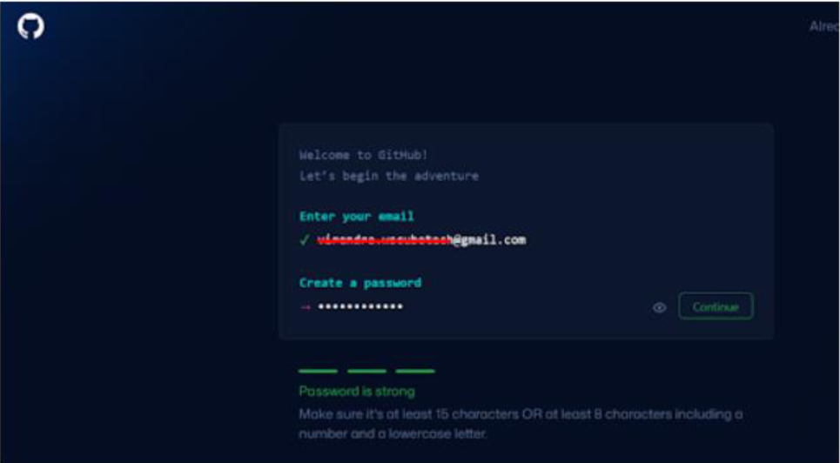

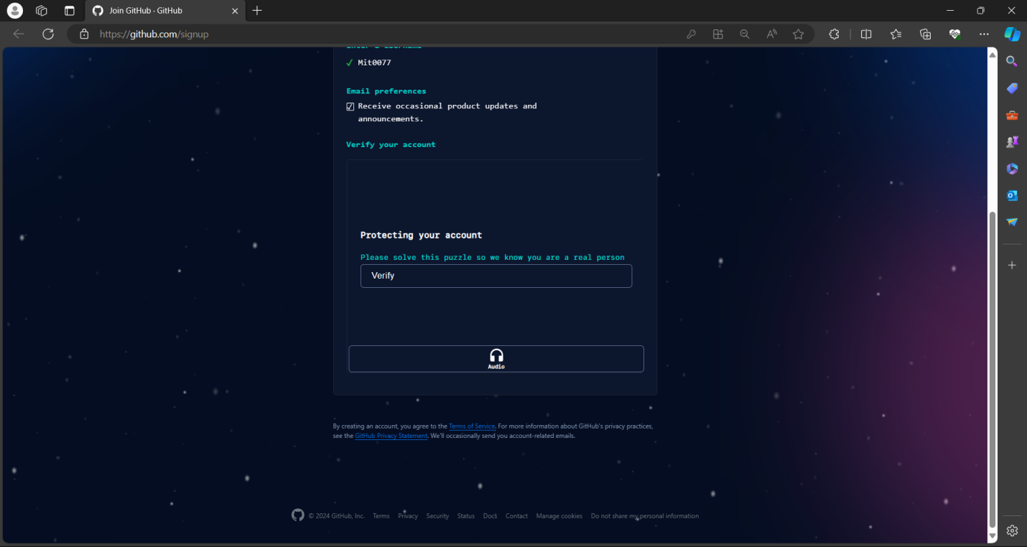

1. Then login to your account.

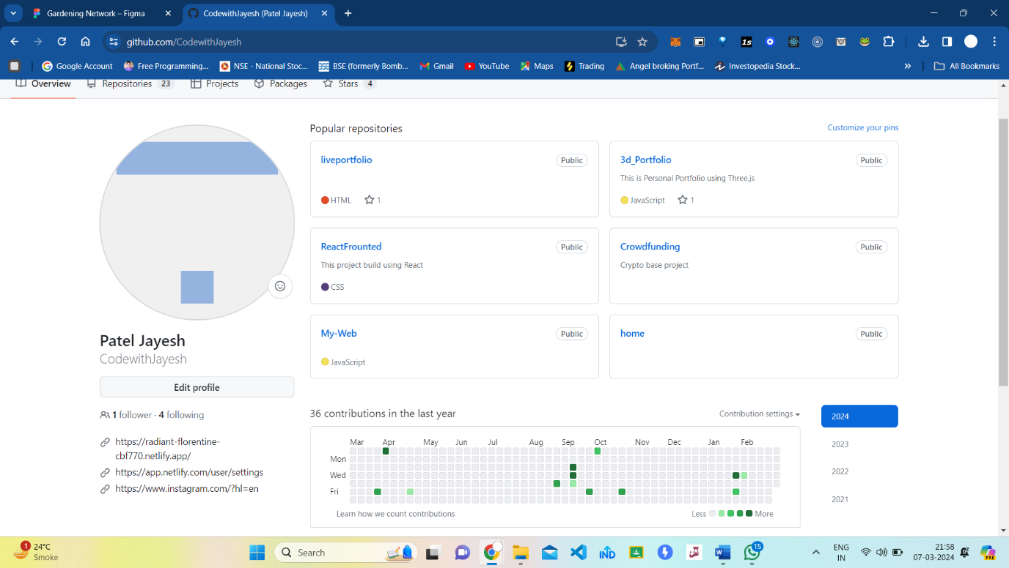

1. Click on new option and enter your repo name”2302031030072”. And select public profile and check create README file. And then click on create repository.

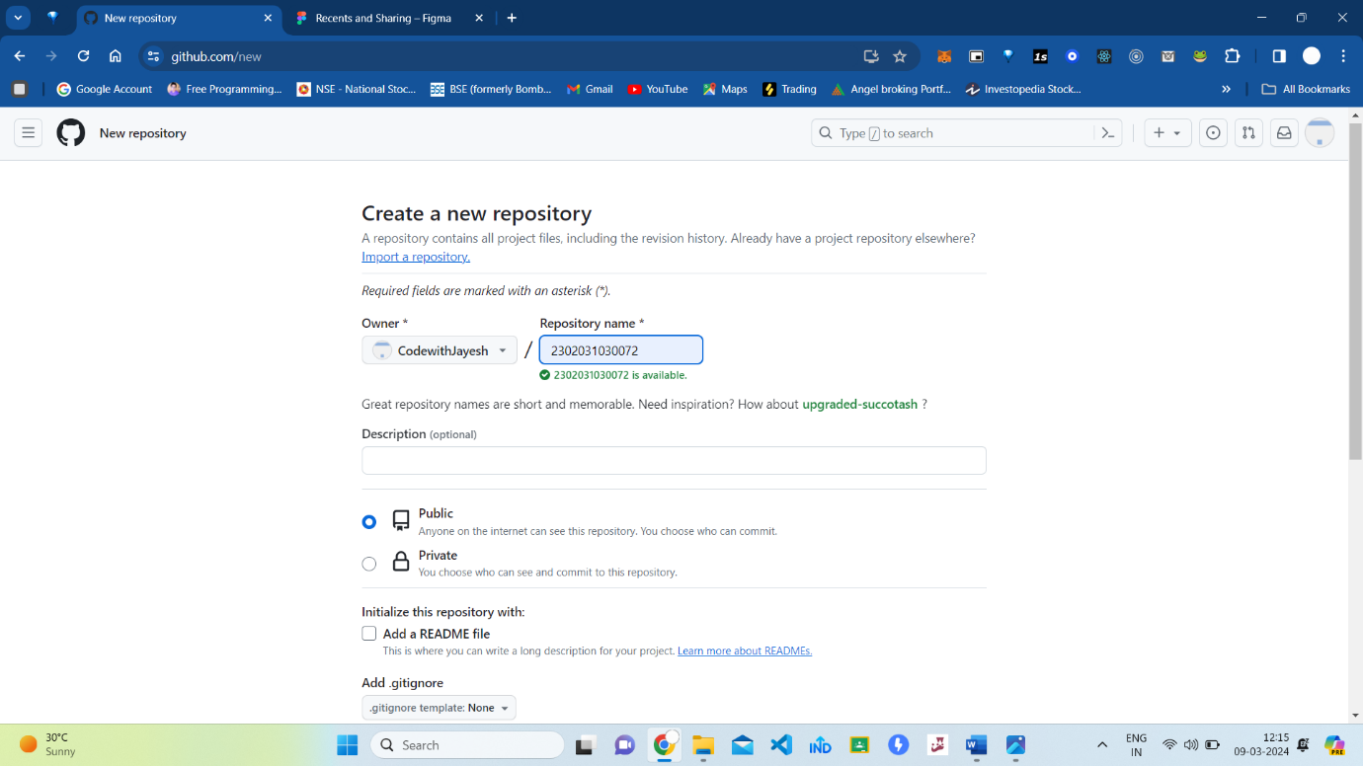

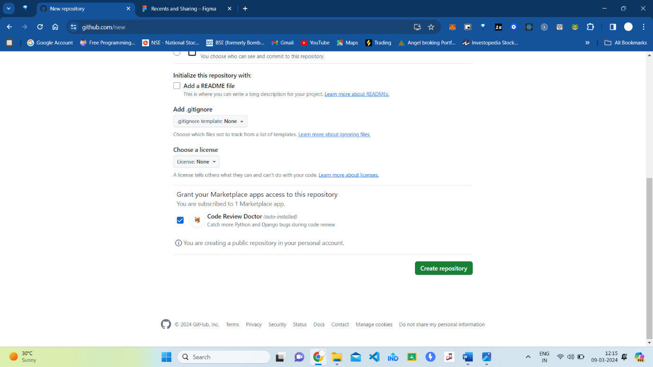

1. And you are successfully done
2. Then go to your repository and click on add file>create new file.

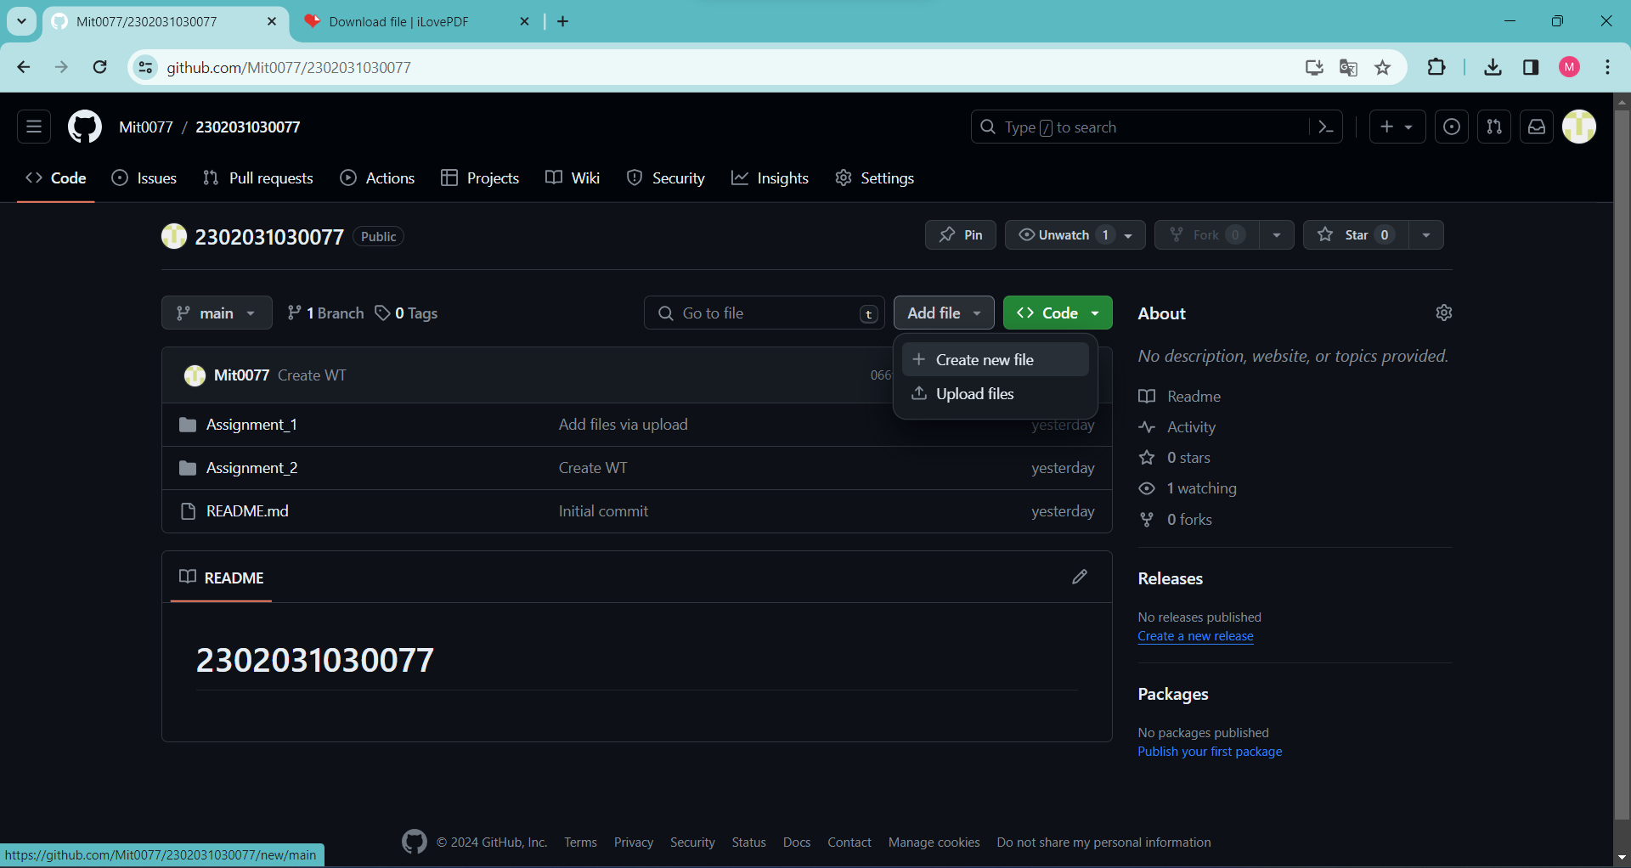

7.Enter the name of your folder”Assignment_1”.and add ”/” to make folder then click on commit changes. 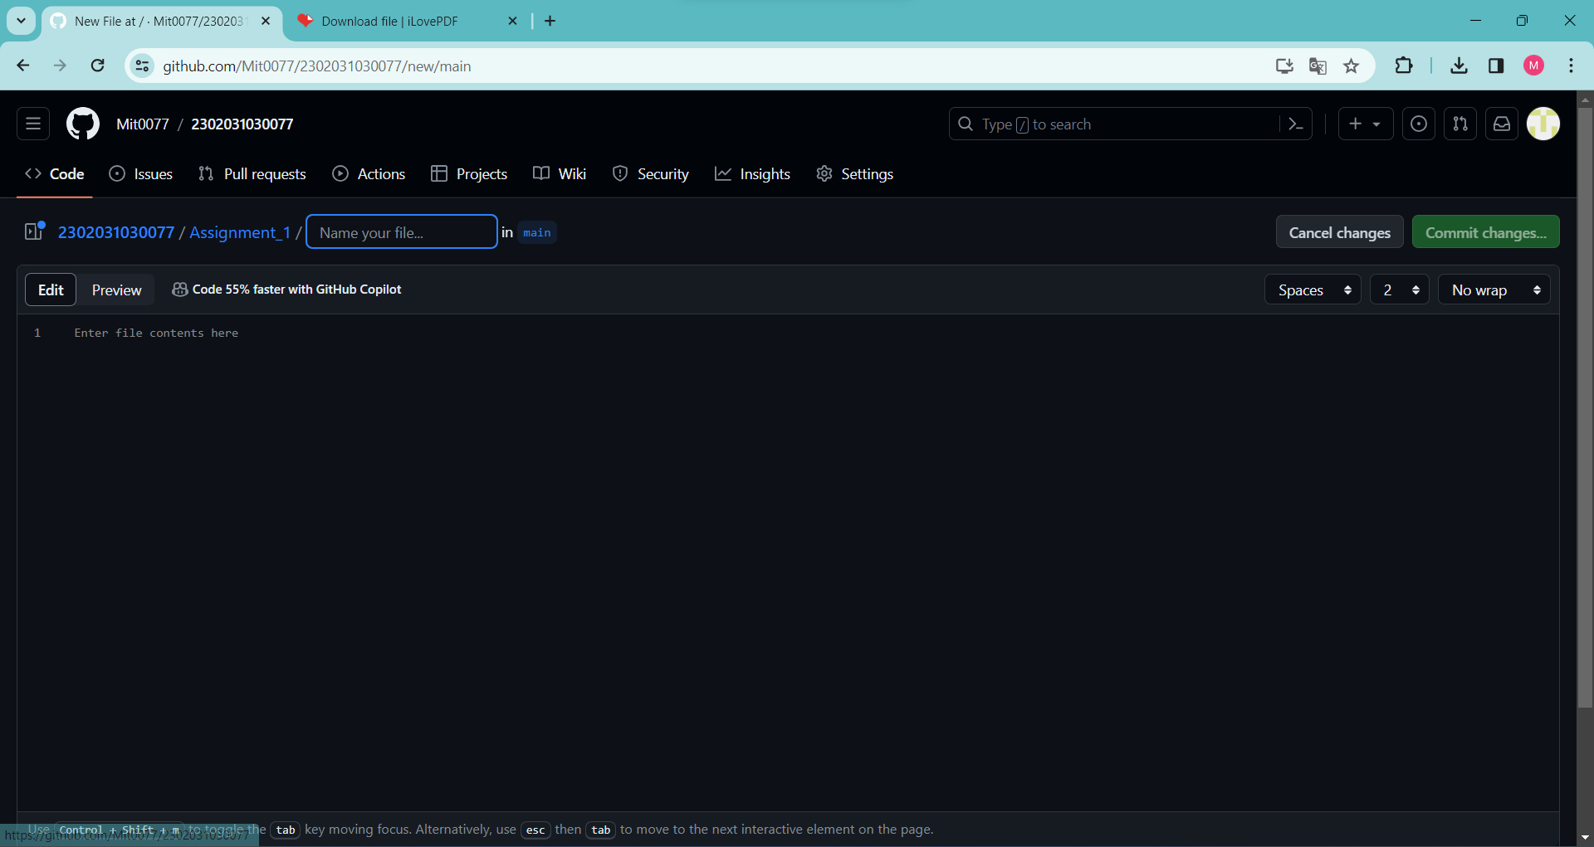

1. You done in making a folder in git hub and it is ready to upload files.